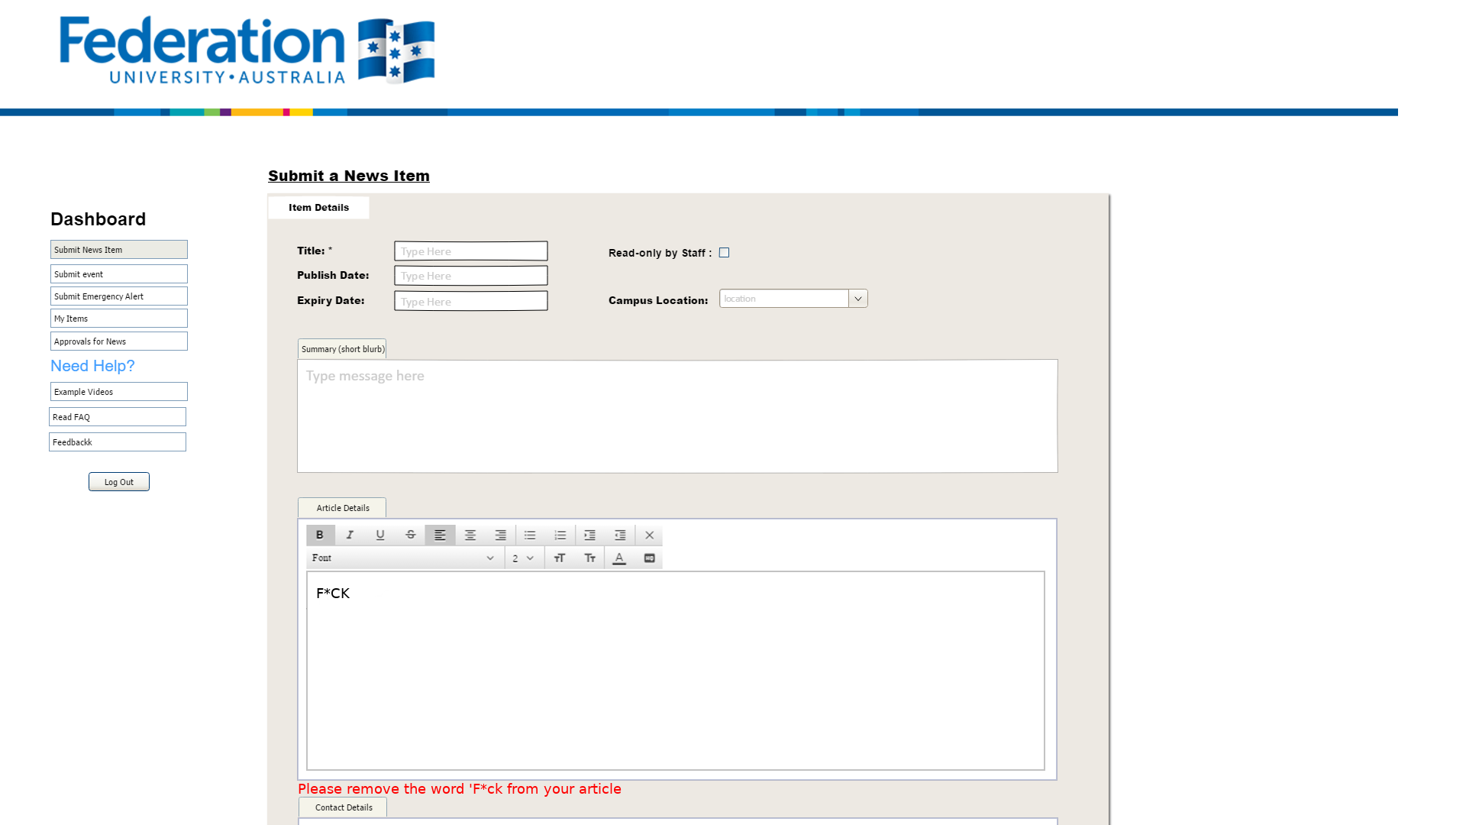

Federation to

UNIVERSITY AUSTRALIA

**Submit a News Item**

**Item Details**

**Dashboard**

Submit News Item

**Title: \***

Type Here

**Read-only by Staff: 0**

Submit event

**Publish Date:**

Type Here

Submit Emergency Alert

**Expiry Date:**

Type Here

**Campus Location:**

location

My Items

Approvals for News

Summary (short blurb)

Need Help?

Type message here

Example Videos

Read FAQ

Feedbackk

Log Out

Article Details

Font

2

TT

TT

A

**F*CK**

Please remove the word 'F*ck from your article

Contact Details